SCHOOLS FOR CLEAN WATER CONTEST

Sample Contest Announcement Newsletter Blurbs and Email Text For Schools
Feel free to use and modify the text below for your contest outreach. They are designed to be engaging and informative, helping spread awareness about the contest and the importance of storm drain maintenance during the fall season!

Sample Text Messages
The Schools for Clean Water contest opened today! Please visit www.SchoolsForCleanWater.org and assign your pledge to our school. Schools with the most support win cash!

Have you visited www.SchoosForCleanWater.org yet? If not, please take a moment to promise to do your part for clean water and assign your promise to our school. Schools with the most support win cash!

Fall is here, and so are the leaves! Don't let them clog local storm drains. Grab your gear and help us win the www.SchoosForCleanWater.org contest. Together, we'll prevent flooding and keep our roads safe!

This is the last week of the Schools for Clean Water Contest. Be sure to visit www.SchoolsForCleanWater.org to pledge to adopt a storm drain and see how our school is doing.

Hey there! Fall is here and we need your help to win the Schools for Clean Water adopt a storm drain contest! Please visit www.SchooslForCleanWater.org today!

Today is your last chance to support our school in the Schools for Clean Water contest. Pledge now and spread the word: www.SchoolsForCleanWater.org

Sample Newsletter Blurbs
Help our School Win the Schools for Clean Water Contest!
Have a curbside storm drain in the street by your home or work? If so, you can help our school win the Schools for Clean Water Contest! Here’s how, visit www.SchoolsForCleanWater.org between October 16th and November 3rd and take the online pledge to adopt a neighborhood storm drain, then assign your pledge to our school! The schools with the most pledges can win money.

Fall is Here, Adopt a Storm Drain and Keep the Water Flowing!
As the fall season sweeps in, so do the falling leaves and rains. Clogged storm drains can lead to local flooding, so let's team up and prevent any soggy surprises. Visit www.SchoolsForCleanWater.org to adopt a neighborhood storm drain, then grab your rakes, shovels, or gloves and clear those storm drains!

Adopt a storm drain and help our school win $$$!
You can help our school by keeping a local storm drain clean. That’s right, we can win up to $1,500 cash in the Schools for Clean Water contest! Visit www.SchoolsForCleanWater.org before the contest ends on November 3rd and pledge to adopt a neighborhood storm drain. Participating is easy, and only takes a few minutes.

Today is your last chance to help us win the Schools for Clean Water contest!
Please take a minute to visit www.SchoolsForCleanWater.org, sign the pledge to adopt a storm drain, and ask a friend (or four) to adopt one, too! With your help our school can win!!

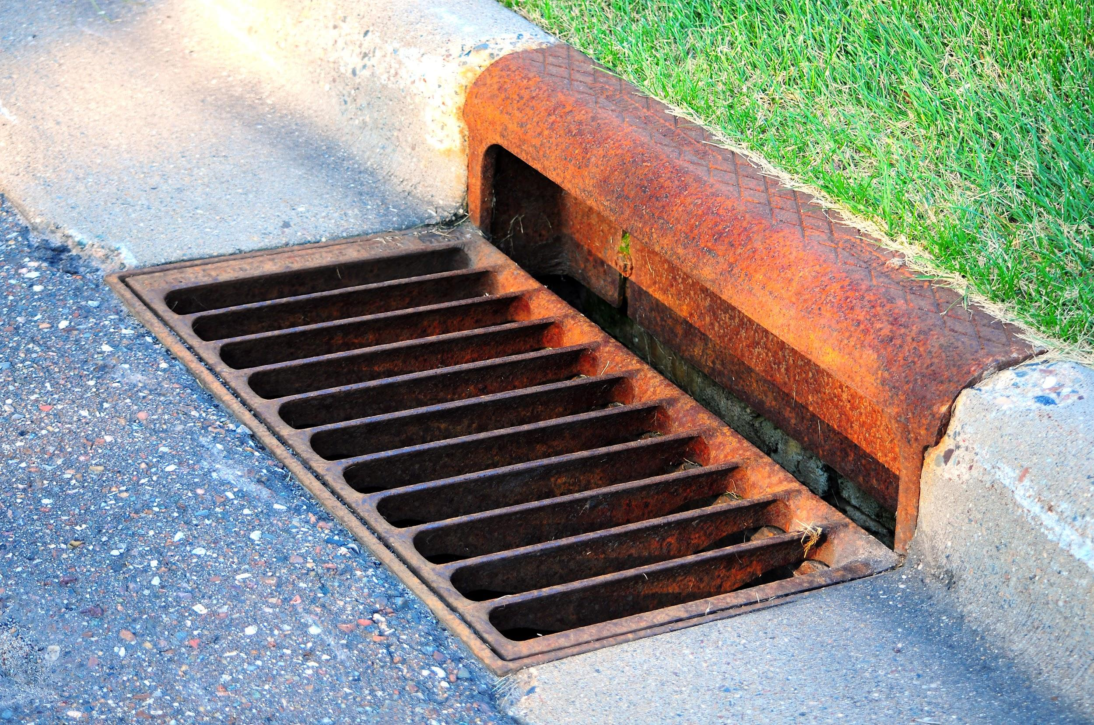

Sample Email #1

Greetings Parents and Guardians,

I’m writing to let you know about an exciting opportunity for our school!

Our school is participating in the Schools for Clean Water Contest and we need your help! It’s an easy online contest where you pledge to adopt a storm drain near your home or work and assign your pledge to our school. If our school gets the most pledges, we can win up to $1,500!

Here are the details:

What’s the Schools for Clean Water Contest?
The Schools for Clean Water Contest is a friendly competition sponsored by the Alliance of Downriver Watersheds to reduce pollution in our local waterways by encouraging residents to adopt a storm drain. When you adopt a storm drain, you promise to keep an eye on it and remove yard waste and trash that is clogging it up.

How does it work?
Visit www.SchoolsForCleanWater.org between October 16th and November 3rd to complete the simple online pledge. When you submit the pledge form, you assign your pledge to our school. Once you’ve pledged, you can also help us win by inviting others to take the pledge and spreading the word on social media. At the end of the contest, the totals are tallied up, and the schools with the most pledges win cash prizes.

Who can pledge?
Anyone 18 and older can take the pledge including, but not limited to: parents, alumni, student's family members, teachers, school staff, friends, neighbors, etc…

What does it mean to "adopt" a neighborhood storm drain?
It means that you commit to check on a curbside storm drain near your home or work and periodically remove litter and yard waste from the storm drain grate.

What do schools win?
Eight schools will win a share of the $5,000 in prize money. The money can be used to pay for educational projects and classroom materials.
- First Place - $1,500
- Second Place - $1,250
- Third Place - $1,000
- Wild Card - 5 x $250 (all schools with 50 or more pledges, will be entered into a random drawing for the five wild card prizes)

Who is sponsoring this contest?
This contest is supported by the Alliance of Downriver Watersheds as a way to work with local schools on a project that benefits the community. Each commitment to adopt a storm drain and keep it clog free will add up to a big reduction in pollution and trash flowing into our local waters. That’s something we can all be proud of!

We are excited to be a part of this contest, and hope you will help us win! Please visit www.SchoolsForCleanWater.org and take the pledge to adopt a storm drain today.

Thank you for your support!

Sample Email # 2

Dear Parent/Guardian,

Did you know that by pledging to adopt a storm drain you can help our school win up to $1,500? Our school is competing in the Schools for Clean Water contest. You can help us win by visiting www.SchoosForCleanWater.org. It only takes a minute or two to fill out the form and pick our school.

Once you’ve pledged, be sure to spread the word about the contest on social media. Please encourage your friends and neighbors to adopt a storm drain on our school’s behalf, too! Everyone wins when our water is cleaner and streets flood less!

Thank you for your support!

Sincerely

Sample Email #3

Dear Parent/Guardian,

Our school needs your help to win the Schools for Clean Water contest. We can win up to $1,500 cash! Just visit www.SchoolsForCleanWater.org between October 16th to November 3rd and pledge to adopt a local storm drain. Participating is easy, it takes just a few minutes of your time.

Here’s how it works:

- Visit the Schools for Clean Water website.
- Take the online pledge to adopt a local storm drain.
- Assign your pledge to our school.
- Track our school’s pledge numbers.
- Encourage friends and family to take the pledge and assign it to our school.
- Spread the word on social media using the hashtags #downrivermichigan and #schoolsforcleanwater.

We are competing with 25 other schools in the ADW area for a share of the $5,000 in prize money. With your help we can be one of the winners!

This project is supported by the Alliance of Downriver Watersheds. Working together with local schools, they hope to encourage residents to adopt a storm drain to reduce neighborhood flooding and keep litter and trash out of local creeks and streams.

We are excited to be a part of this contest, and hope you will help us win!

So why wait? Visit www.SchoolsForCleanWater.org and take the pledge to adopt a storm drain today.

Thank you for your support!!

Sample Email #4

Dear Parent/Guardian,

This is your last chance to help us win in the Schools for Clean Water Contest! The contest closes today at midnight. If you haven’t pledged to adopt a storm drain yet, will you take a moment and do so now? If you have already pledged, you can help by asking friends and family on social media to take the pledge, too.

You might be surprised to learn that most neighborhood storm drains direct rainwater right to local streams and waterways. By pledging to adopt a storm drain you help to stop local flooding and water pollution.

Visit www.SchoolsForCleanWater.org before midnight tonight to pledge to adopt a storm drain and help our school win $$$!!

Thank you for your support!

Sincerely,

